William Adoukonou

[Company name]  [Company address]

Secure System analysis and design Assignment 1

# Contents

Contents 1

Introduction 3

Part A Task 1 – The 2 best SDLCs for this project 4

AGILE Model 4

RAD Model 5

How to make RAD and AGILE more secure 5

Task 2 – Gathering Information for the System 6

Risk Mitigation 7

Task 3 – Diagrams and constraints 8

Data Diagrams 8

Flowchart 9

Data Dictionary 10

Security Constraints 11

Design constraints 11

Costs and Hardware/Software 11

Organisational Policies 11

Timescale constraints 11

Legacy System Constraints 11

Task 4 – Implementation of Design 12

Data Entry form 12

Initial Design 13

Client Feedback 15

Changes Based on Feedback 16

Hardware and Software Requirements 18

Part B Task 1 – Design Evaluation 19

Investigation Techniques 19

Planning 19

Diagrams 19

Overall Security 19

Task 2 – Risk Assessment 20

Security Gap Analysis 21

Conclusion 22

*References* 22

# Introduction

In this assignment, a driving school has asked for help designing their latest project. This includes migrating the old system to the new app.

The 1st section will cover which Software Development Life Cycles are available and their pros/cons. The next topic covers which investigation techniques are available as well as their benefits. This also includes some risk mitigation tactics to help the project run as smooth as possible.

Next is visualisation. Using diagrams such as data flow diagrams, flowcharts and data dictionaries, the client will be able to understand how the new system will operate. These designs will be implemented into a final design based on client feedback. After this, the entire project will be evaluated on its success and how effectively the risks were handled.

# Part A Task 1 – The 2 best SDLCs for this project

Since the system needs to allow quick and easy editing, a software development life cycle that can be changed frequently needs to be used. The best choices would be the AGILE and RAD model.

## AGILE Model

With the AGILE model, the focus is more on user feedback. This is useful for the driving school since they need to meet certain user requirements to improve their experience. It takes the whole project and decomposes it into smaller tasks.

the AGILE cycle runs in a loop allowing each step to be revisited to redesign new versions of the program, making it ideal for this project. The driving school could go through the model with a beta version of the program to test it out and make changes based on the feedback. Some of the benefits include:

Flexibility - Agile is adaptable to “changing requirements and priorities throughout the project lifecycle.” *(apm.org.uk, 2023)*

User oriented - Agile places a strong emphasis on customer collaboration and feedback, resulting in software that meets the customer's needs and expectations. The students that use it will be able to give suggestions on how it can be improved.

Risk reduction - Agile development lessens the chance that a project will fail by releasing functional software in manageable chunks, allowing teams to identify and fix issues as they arise.

The AGILE model is one of the best options for this task however there is some disadvantages. Some of them are:

Experience is needed ­– AGILE is verry communication reliant meaning it would be ideal to have to a skilled team who know how to cooperate.

Time-consuming – It also requires lots of teamwork to be successful, which can be time-consuming and lead to longer development cycles if not managed properly.

Dependency on customer availability - AGILE projects rely heavily on customer feedback, which can be a disadvantage if there aren’t a large enough people to test the application.

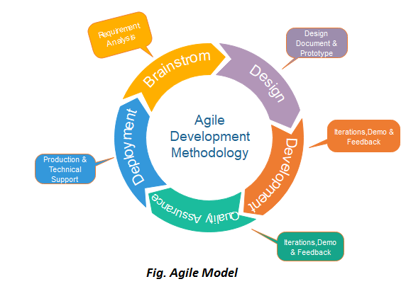

*(javapoint.com, 2023)*

## RAD Model

The 2nd possible model that can be used is the Rapid Application Development Model. RAD or Rapid Application Development is an alternative SDLC which is used like a faster version of the AGILE model. The RAD model is quick and “relies more on making fast changes based on feedback to the original software, rather than creating a whole new one.” *(guru99.com, 2023).* it is highly flexible, allowing for changes to be made throughout the development process, and can improve the final product's quality by identifying and fixing issues early. The RAD model can also help reduce development costs by streamlining the process. Like AGILE, the RAD model doesn’t work for every scenario. Its drawbacks are:

compromising long-term quality - The focus on RAD can cause a lack in quality in the long run. This can lead to technical debt and future maintenance challenges.

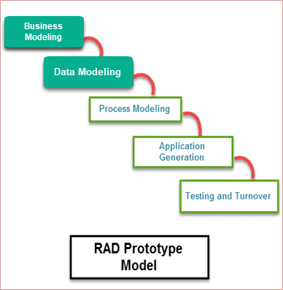Hard to track each version - The RAD model also requires cooperation between developers and users, which can be challenging to manage, especially in larger projects.

*(guru99.com, 2023)*

## How to make RAD and AGILE more secure

To make sure the project goes as smoothly as possible, it’s imperative that cyber security protocols are followed throughout.

Vulnerabilities – the SDLC is based on speed. This means there’s less attention paid to security metrics meaning there can be weak spots in the app. The speed of AGILE also mean there is a lot less documentation which can also bring up more security issues that won’t be reported.

Countermeasures ­– to prevent these issues from causing serious cyber threats, the company should introduce a policy that requires all users involved in the project to submit a cyber security report on each step of the SDLC. This would force everyone to be aware of any exploits regardless of their size.

Policies – when receiving feedback from regarding the system design, they need to consider legislations like the copyright law. This applies to scenarios such as obtaining appropriate licenses for copyrighted material and “ensuring that users are not infringing on others’ copyrights” *(gov.uk, 2021)* through their use of the system.

Legal Obligations – since AGILE is very user oriented, they must make sure they source feedback from 3rd parties ethically. This means complying with the methods listed in the Data Protection Act and not retrieving information from their users without consent.

# Task 2 – Gathering Information for the System

Using appropriate investigation techniques is essential for gathering accurate and reliable information, meeting legal and ethical obligations, and saving time and resources. As mentioned before, the data needs to be collected in an ethical and secure manner with the user’s knowledge. Some techniques that can be used are:

Interview – Setting up a meeting with the client can be beneficial. The client can be specific with the designer with how they want the system to look and perform.

Observation – this is where the designer looks over the current progress of the system, highlights areas of improvement and gets feedback from these changes. This fits with the style of the SDLCs because they both allow for lots of changes.

Questionnaires – If there is no design in place, the client can fill out a few questions that give the designer general directions on how they want the system to look. This is a crucial stage in the design phase since the client can opt for specific features that the system might include.

Out of the examples listed, the questionnaire seemed the most reasonable since it gives the client the chance to add specific features. Here is an example of the questionnaire.

## Risk Mitigation

Risk mitigation is the process of “taking steps to reduce or eliminate the negative impact of potential risks.” *(techtarget.com, 2023).* It involves identifying potential risks, analysing their likelihood and impact, and implementing measures to minimize or control them. Some techniques include reduction, avoidance, transfer and sharing. in regard to the driving school system, it would be beneficial to add the avoidance technique for deadlines in the questionnaire. An extra question will be added to make the client aware of the risk that the deadlines might not be met exactly. Here is the updated table.



# Task 3 – Diagrams and constraints

Data flow diagrams act as a graphical representation of the data flow through a system. The ones below have been designed to show how each step of the system will link in its regular use. How the driving school system acts the main database to communicate and provide information like lesson dates and prices to the students and instructors.

## Data Flow Diagrams – Level 0.

**Level 1 Diagram remove record card add database.**

Student info

Student info

Student info

**Level 2 Diagram**

## Flowchart

When in the design phase for a system, a flowchart is very useful in explaining how the working version will work. The one below shows what happens when a user signs up, books their lessons or test, receives an instructor and when a user is assigned a record ID.

Outputs Student ID

## Data Dictionary

|  |  |  |  |  |  |
| --- | --- | --- | --- | --- | --- |
| Field Name | Data type | Field Size | Source | Input method | Validation check |
| studentName | String | max length = 50 characters | user | User input | Yes |
| instructorName | String | max length = 50 characters | System | Auto – assign | No |
| instructorNumber | String | Length = 11 characters | User | User input | No |
| StudentDOB | String | Max 10 charectars | User | User input | Yes |
| studentNumber | String | Length = 11 characters | user | User input | Yes |
| LessonDate | String | DD/M/YY format | System | Auto – assign | No |
| studentMembership | String | STA = Standar  STA+ = pass + | User/system | User input | Yes |
| LessonLength | Intiger | Min length = 1hr | System | User input | Yes |
| LessonPrice | Float | N/A | System | Auto – assign | Yes |
| TotalPrice | Float | Total of all lessonPrice | System | Auto – assign | Yes |
| studentAddress | String | N/A | User | User input | Yes |
| Instructor_id | string | Max length = 5 charectars | System | Auto-assign | Yes |

Data dictionaries are essential for designing and developing a system. They give someone who may be new to the project an idea of what functions will be used and how they should be configured. This can help with troubleshooting if one of the functions isn’t working as intended.

## Security Constraints

During the design phase of an IT project, security has to be considered to ensure it runs safe and securely. For a driving school, access controls need to be set in place in order to avoid unauthorised access. For example, it would be a major breach of data protection laws if a driving instructor was able to exploit the system and access every user’s name, number, and email.

### Design constraints

The driving school system also needs to be designed securely. This includes not using protocols such as incorrect password limit and encryption. If these features are implemented early, they can be tested and fixed for the initial release.

### Costs and Hardware/Software

A project which requires features such as high security is not cheap. The design phase is where the team needs to set out a budget plan and decide how much is necessary for the driving school app. Increasing the budget can also have negative effects in other areas of the company especially if the final product has lots of errors and needs maintenance.

In addition, the costs of the hardware and software needs to be considered. Components that have more compatibility and increased features are likely to cost more. This also includes any software licenses they may need.

### Organisational Policies

The Design constraints also apply here. The overall design of the system (from the prototype to the final product) needs to be in line with company policies. For example, if a company specialises in Mobiles Apps, the system needs to be compatible with mobile devices.

### Timescale constraints

Setting realistic time constraints is vital in the progress of any project. *(prioritymanagement.com.au, 2023)* says having a project timeline helps you “find a reasonable time to estimate each task”.

### Legacy System Constraints

The original system for the Pass IT school is going to have all the data from the record cards migrated to the new design. This has security constraints since they’re going to be handling sensitive data. The migration has to be done safely or the company could face serious repercussions for data protection violations.

*(Synk.io, 2023)*

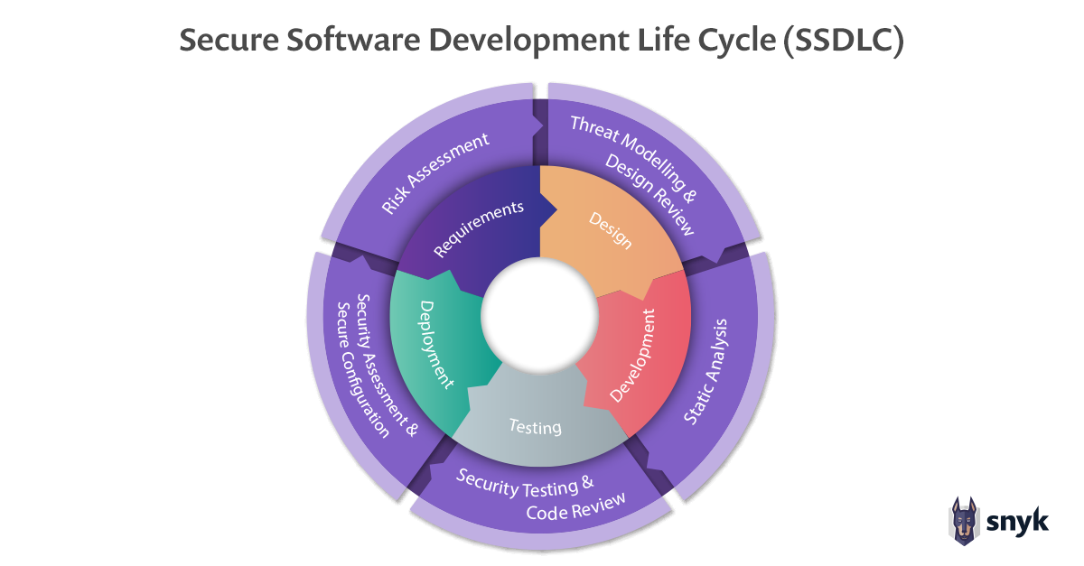

# Task 4 – Implementation of Design

## Data Entry form

Image

Sign up text field.

Name

Email address

Phone Number

Old Card Number

Sign Up

Log In

## A screenshot of a cell phone Description automatically generated with low confidenceInitial Design

## Client Feedback

## Changes Based on Feedback

White text for better user readability

Black background to contrast text.

Secure login system to login

Mobile based design with buttons and smaller icons

+

## Hardware and Software Requirements

Since each of their users will use their own devices, the hardware requirements aren’t as impactful. The main hardware they need is a server with an appropriate amount of storage/HDD (something like RAID technology). It needs to be able to hold all the information that was previously stored on the legacy system. They would also need to do upgrades on their current network to be able to store all the new logins without having issues. This includes switches, routers, and the right cables.

In terms of software, its essential for Pass IT to invest in security software. This includes anti-viruses and firewalls. These tools provide 24/7 monitoring for the server, alerting the user when there is a cyber security breach.



*(ionos.co.uk, 2023)*

*(avast.com, 2023)*

# Part B Task 1 – Design Evaluation

Overall, the project design turned out successfully. It followed some of the security constraints however certain methods could have resulted in a better outcome.

## Investigation Techniques

To gather information about the driving school’s users, the client was given a questionnaire. It helped when designing the system to fit user requirements but in hindsight, an interview would’ve better. *(surveymonkey.co.uk, 2023)* says they allow for a “deeper understanding of topics”. It also allows them to ask more specific questions that they might have come up. This would also be more secure since the interview would be private and couldn’t be intercepted by 3rd parties.

## Planning

The planning of the design could’ve also been improved. On one hand, areas of the plan such as the Data entry form were maintained throughout. The layout is similar to the product finalised by the client. If this project were to be repeated, it would make sense to implement a project plan that highlights how much progress should be done every week. This can benefit the client as well since they know what stage the project is at. This would then let the client keep track of how effective the security metrics are and if more need adding.

## Diagrams

When comparing the final design to the diagrams, it turned out successful. The final design works how the data flow diagram intended and the flowchart operation is also followed. To improve the diagrams, a simpler design could be added. An example could be a standard flowchart with less features so that less experienced clients can understand how the program will function. It could even be a diagram of the old system to show a comparison. In terms of security. To improve the security of the diagrams, they could be created using a secure designer. These include safety features such as access control and encryption to make sure they only end up in the right hands.

## Overall Security

Security throughout the design could have been focused on more. One weakness is the lack of frequent security updates. This links in with the planning since the idea of a project plan could fix this issue. Because the SDLC chosen relies on fast paced working, having the proposed idea of a cyber security report would help combat safety issues while keeping the company in the loop.

# Task 2 – Risk Assessment

As mentioned before, it’s important to identify potential risks, analyse their likelihood and impact, and implement measures to minimize or control them. An institution called The National Institute of Standards and Technology or NIST specialises in this. Their main goal is to “break down the standards that allow technology to work seamlessly” *(nist.gov, 2023).* They do this via their main “standards” that companies should follow for a risk-free project. These include:

Categorize – Make sure the data that needs protection is sorted properly (such as student names separate from instructor names)

Plan – *(digitalguardian.com, 2023)* says you should “Develop a baseline for the minimum controls required to protect the information”. In this case they should limit how many people can access all student names addresses.

Assess – the next step is to conduct the risk assessment to evaluate the current controls and search for areas of improvement.

Document – after testing which metrics work. They should be then added to a security plan.

Implementation – roll out the security plan. In this case, the driving school app would include the security features in the initial design and would be tweaked based on client feedback.

Testing ­– the NIST standards focus on the repetition of testing, monitoring the performance and adding to the security plan. After this you should determine the severity level of each risk that was combated by the plan

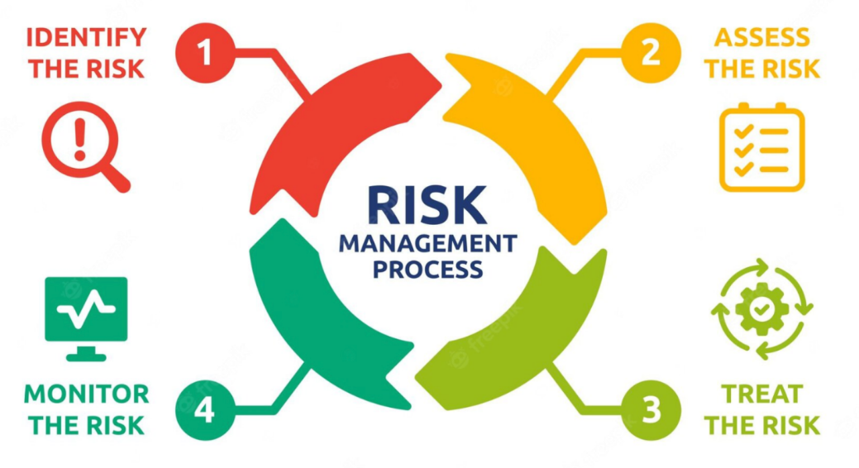

*(linkedin.com, 2022)*

## Security Gap Analysis

A security gap analysis is similar to a risk assessment. Companies such as Intersys use them to give companies “insights into the current status of its cyber security approaches and vulnerabilities” *(intersys.co.uk, 2022)*. It takes the current security practices and compares it against the best methods, even the ones mentioned by the NIST. For the Pass IT School project, it would work by doing the following steps:

Full Security Audit – as mentioned before, the security audit is when a company does a system inspection to make sure all security measures are in place *(intersys.co.uk, 2022).* The driving school should do this 1st “to get an understanding of what measures are already in place.” This also gives a good idea of what risks there are.

Threat Matrix – when the threats have been identified, they can then go into a threat matrix. This acts as a real time document ranking the severity of each risk allowing the team to prioritize what risks to combat 1st.

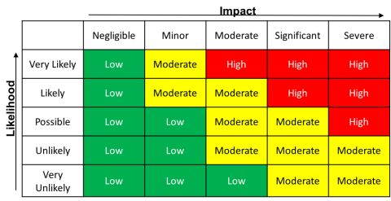in this case risks such as student and instructor information would be major risk and top priority whereas a simple bug would be dealt with later on.

*(itsecurity.uiowa.edu, 2023)*

Countermeasures – Now the driving school is aware of the threats that can occur in the system, they can figure out the countermeasures to tackle the threats. The most likely causes are “lack of monitoring” and “employees not following best practice”. *(intersys.co.uk, 2022).* In that case it would be best to invest in a new virus and firewall for the system. This would help staff monitor activity at all times. They should also include staff training to give employees the skills they need when fighting off cyber-attacks.

# Conclusion

To summarise, AGILE and RAD models are useful for this project for their flexibility and speed. Once the SDLC for the project is determined, its useful to gather information from the client. This can be done with interviews, questionnaires, or other methods. To give the client a better understanding of how the new network will work its useful to add DFDs and flowcharts. Before the final design is final is published, its always good to get some feedback to improve the design.

Although each project is different, its good to evaluate the methods used including planning, security consideration and investigation techniques.

# *References*

*What Is Agile Project Management? | APM Methodology & Definition. 2023. What Is Agile Project Management? | APM Methodology & Definition. [ONLINE] Available at: https://www.apm.org.uk/resources/find-a-resource/agile-project-management/. [Accessed 01 March 2023].*

*Guru99. 2023. What is RAD Model? Phases, Advantages and Disadvantages. [ONLINE] Available at: https://www.guru99.com/what-is-rad-rapid-software-development-model-advantages-disadvantages.html. [Accessed 08 March 2023].*

*www.javatpoint.com. 2023. Agile Model (Software Engineering) - javatpoint. [ONLINE] Available at: https://www.javatpoint.com/software-engineering-agile-model. [Accessed 08 March 2023].*

*Guru99. 2023. What is RAD Model? Phases, Advantages and Disadvantages. [ONLINE] Available at: https://www.guru99.com/what-is-rad-rapid-software-development-model-advantages-disadvantages.html. [Accessed 08 March 2023].*

*GOV.UK. 2023. Copyright Act - GOV.UK . [ONLINE] Available at: https://www.gov.uk/government/publications/copyright-acts-and-related-laws. [Accessed 13 March 2023].*

*GOV.UK. 2023. Copyright Act - GOV.UK . [ONLINE] Available at: https://www.gov.uk/government/publications/copyright-acts-and-related-laws. [Accessed 13 March 2023].*

*GOV.UK. 2023. Copyright Act - GOV.UK . [ONLINE] Available at: https://www.gov.uk/government/publications/copyright-acts-and-related-laws. [Accessed 13 March 2023].*

*PMClickmanDev. 2023. Why are Project timelines important? - Priority Management. [ONLINE] Available at: https://www.prioritymanagement.com.au/why-are-project-timelines-important/#:~:text=The%20main%20advantage%20of%20a,the%20beginning%20of%20the%20next.. [Accessed 23 April 2023]*

*Snyk. 2023. Secure SDLC | Secure Software Development Life Cycle | Snyk. [ONLINE] Available at: https://snyk.io/learn/secure-sdlc/. [Accessed 03 May 2023].*

*IONOS Digital Guide. 2023. What is RAID 0? Definition and function - IONOS. [ONLINE] Available at: https://www.ionos.co.uk/digitalguide/server/security/raid-0/. [Accessed 03 May 2023].*

*How to use Avast Firewall | Avast. 2023. How to use Avast Firewall | Avast. [ONLINE] Available at: https://support.avast.com/en-gb/article/use-antivirus-firewall/#pc. [Accessed 03 May 2023].*

*SurveyMonkey. 2023. Survey vs Interview for Research: Differences | SurveyMonkey. [ONLINE] Available at: https://www.surveymonkey.co.uk/mp/survey-vs-interview/#:~:text=Because%20of%20their%20one%2Don,clarify%20what%20the%20respondent%20meant.. [Accessed 10 May 2023].*

*NIST. 2023. Standards | NIST. [ONLINE] Available at: https://www.nist.gov/standards. [Accessed 15 May 2023].*

*Martin Philp. 2023. Cyber Security Gap Analysis | Why You Need One | Intersys Blog. [ONLINE] Available at: https://intersys.co.uk/2022/10/07/why-every-business-needs-a-cyber-security-gap-analysis/#:~:text=A%20cyber%20security%20gap%20analysis%20provides%20an%20organisation%20with%20insights,cyber%20security%20approaches%20and%20vulnerabilities.. [Accessed 16 May 2023].*

*How to Perform a Cyber Security Risk Assessment. 2023. How to Perform a Cyber Security Risk Assessment. [ONLINE] Available at: https://www.linkedin.com/pulse/how-perform-cyber-security-risk-assessment-michael-benis?trk=pulse-article. [Accessed 16 May 2023].*

*How to Perform a Cyber Security Risk Assessment. 2023. How to Perform a Cyber Security Risk Assessment. [ONLINE] Available at: https://www.linkedin.com/pulse/how-perform-cyber-security-risk-assessment-michael-benis?trk=pulse-article. [Accessed 16 May 2023].*

*How to Perform a Cyber Security Risk Assessment. 2023. How to Perform a Cyber Security Risk Assessment. [ONLINE] Available at: https://www.linkedin.com/pulse/how-perform-cyber-security-risk-assessment-michael-benis?trk=pulse-article. [Accessed 16 May 2023].*